Init

Creates a new repo

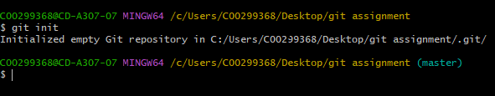

Creates a new hidden .git file

